Development Guide

jWebSocket
Monitoring resources of computers
Orlando Miranda Gómez
Version 1.0
- Overview
The monitoring demo allows users to set up a stable and continuous monitoring of the resources of a computer in real time. You can view the status of resources from a computer or from a cell phone, just having a web browser that supports WebSocket protocol, which provides high speed and real-time work. Was developed with the jWebSocket framework.
- Infrastructure, Model, Approach
Monitoring Application Demo implements the layered architecture, allowing separate business logic from the logic of design. Monitoring architecture is divided into two main layers: Browser that represents the Presentation Layer and jWebSocket server representing Business Layer. The application does not have the data layer because this not uses Database for your operation. Furthermore, the development can be carried out at various levels and in case there occurs a change, only affects the required level without having to check between codes mixing.
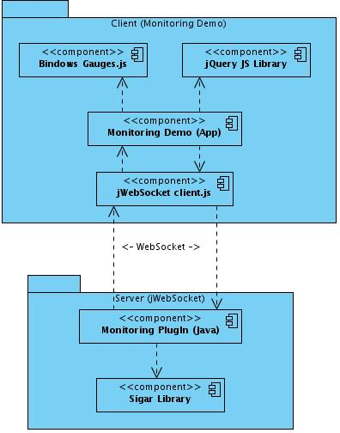
The Monitoring Demo application works by Bindows Gauges that is a Java Script library and used as templates for displays XML files called ADF (Application Description Files), and runs only on the client side. The application receives the data through the jWebSocket client and consumes features of the jQuery library. JWebSocket client communicates with the server using WebSocket protocol and this jWebSocket server contains the monitoring plugin that communicates with the Sigar library that is responsible for obtaining any information of computer resources.
This demo was developed using TokenPlugin as it is a lower-level structure in which you do not have many features and is easy to process messages, it is best to use since the application will work with higher performance.
- Requistes and prerequistes
The requirements for the continued development of the Monitoring Demo application are:
- Connecting to the network.
- Use and copy the native library libsigar-x86-linux.so of Sigar in /usr/lib.
- External Data: use of xml gauges designed for each resource.
Configuring Maven
JWebSocketMonitorigPlugIn module is configured via pom.xml file, an XML representation of the Maven project within the project folder to configure the dependencies and basic properties of the project.
This file contains various components of Maven, including maven-assembly-plugin, this allows you to export all sources jWebSocketMonitoringPlugin-1.0.jar file, and then you will see how it is used:
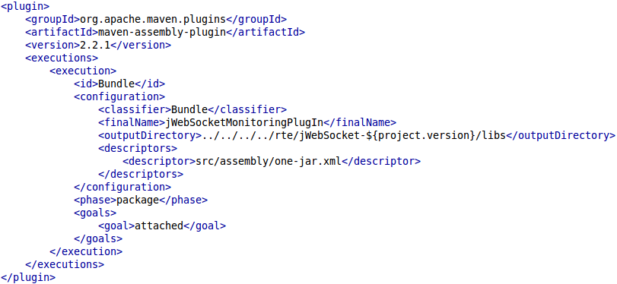
After compiling the project, in the folder rte/jWebSocket-1.0/libs/ copied the sources in the file jWebSocketMonitoringPlugIn-1.0.jar.
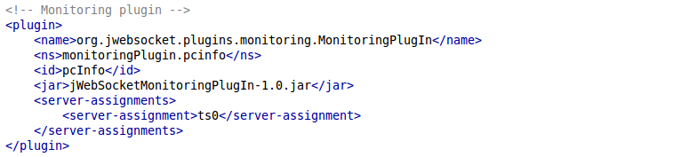
The monitoring plugin settings can be managed in rte/jWebSocket-1.0/conf/jWebSocket.xml, where you can also configure other plugins. Below is the plugin configuration for jWebSocket:

- Modules, Structure
The Monitoring plugin is within jWebSocketMonitoringPlugIn module in the table shown below shows the structure that has this demo:
Project name: | Monitoring Demo
Location of the sources in the SVN server: | Client | Server
Location of the sources in the SVN server: | https://jwsdev.org:9443/svn/jWebSocket/branches/jWebSocket-1.0/jWebSocketClient/web/demos/jwsMonitoring/ | https://jwsdev.org:9443/svn/jWebSocket/branches/jWebSocket-1.0/jWebSocketPlugIns/jWebSocketMonitoringPlugIn/
SVN branch: | jWebSocket-1.0
Maven Dependency: | 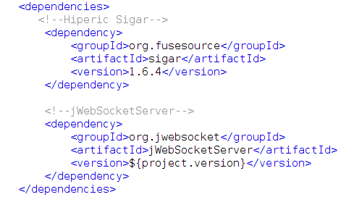
JAR module: | jWebSocketMonitoringPlugIn-1.0.jar
Packet structure: | Space of base name:  org.jwebsocket.plugins.monitoring  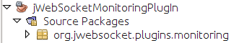
org.jwebsocket.plugins.monitoring:
Contains the mains classes of the module that allows for monitoring management framework jWebSocket.

Client side:
We used the jQuery framework. The client libraries and classes for Monitoring Demo application are available in the JavaScript language and are stored in the /demos/jwsMonitoring.
Server side:
We used the framework jWebSocket. We have the plugin MonitorinPlugIn that receives tokens and send data from your computer.
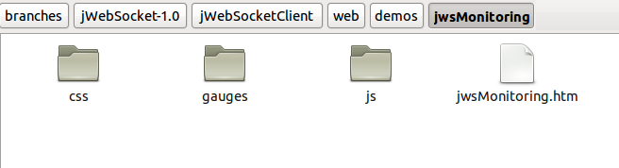
Source code structure
Client:

Description of elements:
css: This directory contains the file that gives style to client components.
gauges: This directory contains xml files for the settings of all the clocks that are used with the library bindows_gauges.js.
js: This directory stores all the files of the libraries used in the client and Java Script files.
jwsMonitoring.htm: This file is set to any HTML application.
Server:
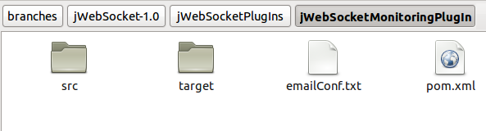
Description of elements:
src: This directory contains all the source code of classes and libraries of the solution.
target: This directory temporarily stores the compiled source code, its content is not included in the version control.
emailConf.text: File to set the necessary parameters for email notification.
pom.xml: Configuration files for jWebSocketServer module that contains information about the project and details of the settings used by Maven to build the project.
- Source Code

Standard of code

To develop the application used the standard of code of the jWebSocket framework.
Detailed description of the application code
Detailed explanation of the most important customer of monitoring:
monitoring.js
Method | Description
updateGauge() | Get the token "Information" of the server and updates the clocks.
resetGauges() | Sets all values ​​to "0" when the server is stopped.
loadGaugeIntoDiv() | Loads the meters or clocks on the page through a Div.
setValue() | Enter the values ​​to clocks to update dynamically.
setText() | Enter the values ​​in the texts of the clocks.
setEndValue( parseInt( aToken.totalHddSpace) ) | To define the total value on the clock that has the system's hard drive.
toFixed(1) | To obtain values ​​of a place after the comma.
Detailed explanation of the functions of the server and the library used:
MonitoringPlugIn
Type | Method | Description
void | engineStarted (WebSocketEngine aEngine) | Start the application.
void | engineStopped ( WebSocketEngine aEngine) | Stops the application properly.
void | connectorStarted ( WebSocketConnector aConnector) | Chain runs inside jWebSocket server when a user connects to MonitoringPlugin.
void | connectorStopped ( WebSocketConnector aConnector, CloseReason aCloseReason) | Chain runs inside jWebSocket server when a user disconnects from MonitoringPlugin.
void | processToken ( PlugInResponse aResponse, WebSocketConnector aConnector, Token aToken) | Processes the received token and adds or deletes a connector to the customer list. The token can be either register or unregister.
void | broadcastInfo() | Create the token "information" to information from the memory, hard disk, CPU and sends it to the list of clients connected to the plugin.
java.lang.String | showMemInfo() | Create a string array which stores all information in the report obtained through Sigar class.
java.lang.String | getInMBytes ( long aValue) | Converts the value of type long memory and returns received by the amount of the type (Kb, Mb or Gb).
java.lang.String | getInMeasure ( long aValue) | Converts hard disk data from long to the type of unit of measure that corresponds to (Kb, Mb and Gb).

Sigar
Type | Method | Description
Mem | getMem() | Obtains the object relating to the RAM.
Swap | getSwap() | Gets the reference to the Swap.
long | getTotal() | Returns the total computer memory.
long | getActualUsed() | Returns the memory used at the time.
long | getUsed() | Returns the value of the Swap used.
double | getUsedPercent() | Returns the value of the used memory in percent.
double | getFreePercent() | Returns the value of free memory in percent.
CpuPerc | getCpuPerc() | Get system information from the CPU in percentage format.

- Interfaces
Protocol Used
Monitoring Demo application is built on the jWebSocket framework, technology-oriented application development using the WebSocket protocol to provide high levels of speed, security and real-time work, plus provide a bidirectional communication channel and full-duplex over a single TCP socket to communicate.
Data format used
This application uses xml for the design of the client, using the meters that are developed in this format and has the bindows_gauges.js library that has the Bindows framework.

- Frameworks, libraries and tools
Frameworks:
jWebSocket
Besides being a framework of open source is a technology oriented web application development based on stationary and mobile Java on the server side and JavaScript on the client side. jWebSocket establishing a token model as abstract data through a hierarchical structure and API provide methods to access the contents. In order to make an abstraction in the handling of different formats, the framework converts the data packets incoming and outgoing tokens.
jWebSocket as a Web server provides an important set of features and its extensible architecture with plugins to easily add additional features to an independent system. In a cluster components can be used as services, so jWebSocket perfectly compatible with SOA in an environment based on events. These features show the strength and flexibility of the framework for the development of stationary and mobile Web applications, multi-sectoral and compatible with all browsers.
The jWebSocket framework through WebSocket communication provides high levels of speed, scalability, security and work in real time.
jQuery
It is a library or JavaScript framework. Simplifies the way people interact with HTML documents, manipulate the DOM, handling events and develop animations, achieving great results in less time and space.

Its main feature is that you can change the contents of a Web page without recharging, by manipulating the DOM and AJAX requests. It also allows interactivity and DOM tree modifications, including support for CSS 1-3 and basic XPath component. It has several utilities to obtain information from the browser, operating with objects, vectors, functions, among others. It is compatible with Mozilla Firefox 2.0 +, Internet Explorer 6 +, Safari 3 +, Opera 10.6 + and Google Chrome 8 +.
The library that is used on the server side is Hyperic Sigar, version 1.6.4. This is a System Information Collector and Reporter, giving our computer data. It is also a multi-platform API that cross-language library and command-line tool can access the operating system and hardware level information in Java, Perl and NET. For more information about this library please visit the following links:
http://support.hyperic.com/display/SIGAR/Home http://www.hyperic.com/products/sigar.
The client libraries and classes for Monitoring Extension are available only to the Java language and scripts are stored in the file jwsEventsPlugIn.js. The requirements of external libraries in the client side are:
Library | Description
jWebSocket.js | JWebSocket client library for Java Script, license LPGL.
bindows_gauges.js | Version 1.1 beta3, to display the data dynamically as watches. http://www.bindows.net/worldwide/LatinAmerica.html
jQuery.js | Version 1.5.1, license GPL y MIT. To work with the client-server connection.

- Database and date persistent
MonitoringPlugIn module does not require the use of a database operation.
- Hardware
MonitoringPlugIn The module does not require the use of additional hardware to operate; only the internal computer that are necessary for checking through this application.

- References
org.jwebsocket.plugins.monitoring

Class MonitoringPlugIn
- java.lang.Object
- org.jwebsocket.plugins.BasePlugIn
- org.jwebsocket.plugins.TokenPlugIn.
- org.jwebsocket.plugins.monitoring.MonitoringPlugIn

- All Implemented Interfaces:
org.jwebsocket.api.WebSocketPlugIn

public class MonitoringPlugIn
extends org.jwebsocket.plugins.TokenPlugIn
Version:
1.0
Author:
Merly, Orlando

Constructor Summary
Constructors
Constructor and Description
MonitoringPlugIn(org.jwebsocket.api.PluginConfiguration aConfiguration)
Creates the plugin logs Creates an object of Mongo and the date format

Method Summary
Methods
Modifier and Type | Method and Description
void | broadcastBrowsersInfo(org.jwebsocket.api.WebSocketConnector aConnector)  To create token about the browser information
void | broadcastServerXchgInfo(org.jwebsocket.api.WebSocketConnector aConnector)  To create token about Server Exchange Information
void | broadcastServerXchgInfoPreviousDate(org.jwebsocket.api.WebSocketConnector aConnector, java.lang.String aDay, java.lang.String aMonth, java.lang.String aYear)
void | broadcastServerXchgInfoXDay(org.jwebsocket.api.WebSocketConnector aConnector, java.lang.String aMonth)  To create token about Server Exchange Information X Day
void | broadcastServerXchgInfoXMonth(org.jwebsocket.api.WebSocketConnector aConnector, java.lang.String aYear)  To create token about Server Exchange Information X Month
void | broadcastUserInfo(org.jwebsocket.api.WebSocketConnector aConnector)  To create token of the user information
org.jwebsocket.token.Token | computerInfoToToken()  To create token of the computer information
void | connectorStarted(org.jwebsocket.api.WebSocketConnector aConnector)  To add users online
void | connectorStopped(org.jwebsocket.api.WebSocketConnector aConnector, org.jwebsocket.kit.CloseReason aCloseReason)  To stop the connector of websocket and know the reasons
void | engineStarted(org.jwebsocket.api.WebSocketEngine aEngine)  To start the threads
void | engineStopped(org.jwebsocket.api.WebSocketEngine aEngine)  To stop the threads
int[] | gatherMemInfo()  To obtain all information about the memories
void | processToken(org.jwebsocket.kit.PlugInResponse aResponse, org.jwebsocket.api.WebSocketConnector aConnector, org.jwebsocket.token.Token aToken)  To process token of the server exchange information Add or remove a connector to the client list

Methods inherited from class org.jwebsocket.plugins.TokenPlugIn
broadcastToken, broadcastToken, createAccessDenied, createReasonOfChange, createResponse, getConfigBeanFactory, getNamespace, getServer, invoke, processPacket, sendErrorToken, sendToken, sendTokenAsync, setNamespace

Methods inherited from class org.jwebsocket.plugins.BasePlugIn
addString, clearSettings, getConnector, getConnectorCount, getEnabled, getId, getJSON, getJSON, getName, getNode, getNodeId, getPlugInChain, getPluginConfiguration, getSettings, getString, getString, getUsername, getVersion, processEnabled, removeNodeId, removeSetting, removeUsername, setEnabled, setNodeId, setPlugInChain, setUsername, setVersion

Methods inherited from class java.lang.Object
clone, equals, finalize, getClass, hashCode, notify, notifyAll, toString, wait, wait, wait

Constructor Detail

MonitoringPlugIn
public MonitoringPlugIn(org.jwebsocket.api.PluginConfiguration aConfiguration)
Creates the plugin logs Creates an object of Mongo and the date format
Parameters:
aConfiguration - Plugin configuration

Method Detail

engineStarted
public void engineStarted(org.jwebsocket.api.WebSocketEngine aEngine)
To start the threads
Specified by:
engineStarted in interface org.jwebsocket.api.WebSocketPlugIn
Overrides:
engineStarted in class org.jwebsocket.plugins.TokenPlugIn
Parameters:
aEngine - WebSocketEngine

engineStopped
public void engineStopped(org.jwebsocket.api.WebSocketEngine aEngine)
To stop the threads
Specified by:
engineStopped in interface org.jwebsocket.api.WebSocketPlugIn
Overrides:
engineStopped in class org.jwebsocket.plugins.TokenPlugIn
Parameters:
aEngine - WebSocketEngine

connectorStarted
public void connectorStarted(org.jwebsocket.api.WebSocketConnector aConnector)
To add users online
Specified by:
connectorStarted in interface org.jwebsocket.api.WebSocketPlugIn
Overrides:
connectorStarted in class org.jwebsocket.plugins.TokenPlugIn
Parameters:
aConnector - A websocket connector

connectorStopped
public void connectorStopped(org.jwebsocket.api.WebSocketConnector aConnector,
org.jwebsocket.kit.CloseReason aCloseReason)
To stop the connector of websocket and know the reasons
Specified by:
connectorStopped in interface org.jwebsocket.api.WebSocketPlugIn
Overrides:
connectorStopped in class org.jwebsocket.plugins.TokenPlugIn
Parameters:
aConnector - A websocket connector
aCloseReason - Reason that the connector was closed

processToken
public void processToken(org.jwebsocket.kit.PlugInResponse aResponse,
org.jwebsocket.api.WebSocketConnector aConnector,
org.jwebsocket.token.Token aToken)
To process token of the server exchange information Add or remove a connector to the client list
Overrides:
processToken in class org.jwebsocket.plugins.TokenPlugIn
Parameters:
aResponse -
aConnector -
aToken -

computerInfoToToken
public org.jwebsocket.token.Token computerInfoToToken()
To create token of the computer information
Returns:
token list

broadcastUserInfo
public void broadcastUserInfo(org.jwebsocket.api.WebSocketConnector aConnector)
To create token of the user information
Parameters:
aConnector -

broadcastServerXchgInfo
public void broadcastServerXchgInfo(org.jwebsocket.api.WebSocketConnector aConnector)
To create token about Server Exchange Information
Parameters:
aConnector -

broadcastServerXchgInfoPreviousDate
public void broadcastServerXchgInfoPreviousDate(org.jwebsocket.api.WebSocketConnector aConnector,
java.lang.String aDay,
java.lang.String aMonth,
java.lang.String aYear)

broadcastServerXchgInfoXDay
public void broadcastServerXchgInfoXDay(org.jwebsocket.api.WebSocketConnector aConnector,
java.lang.String aMonth)
To create token about Server Exchange Information X Day
Parameters:
aConnector -
aMonth -

broadcastServerXchgInfoXMonth
public void broadcastServerXchgInfoXMonth(org.jwebsocket.api.WebSocketConnector aConnector,
java.lang.String aYear)
To create token about Server Exchange Information X Month
Parameters:
aConnector -
aYear -

broadcastBrowsersInfo
public void broadcastBrowsersInfo(org.jwebsocket.api.WebSocketConnector aConnector)
To create token about the browser information
Parameters:
aConnector -

gatherMemInfo
public int[] gatherMemInfo()
throws org.hyperic.sigar.SigarException
To obtain all information about the memories
Returns:
Array of the memories datas
Throws:
org.hyperic.sigar.SigarException

